**Data Types Practice Solutions**

**As always, please reach out if you have any questions or just want any practice. If you are more experienced with Python and think there is an easier way to do something, let us know! (but it has to be something we have taught so far, we know there are easier ways in general!)**

**Strings Practice:**



**Mad Libs Clone v2:**



**Dictionary Practice:**

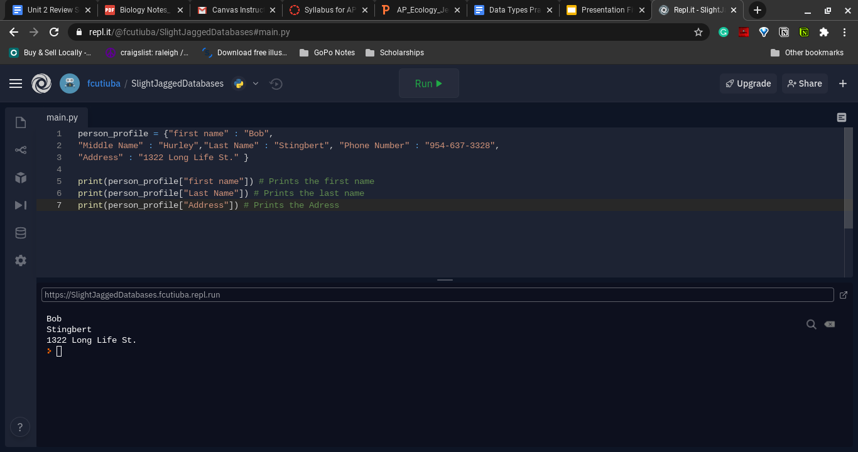

**List Practice:**

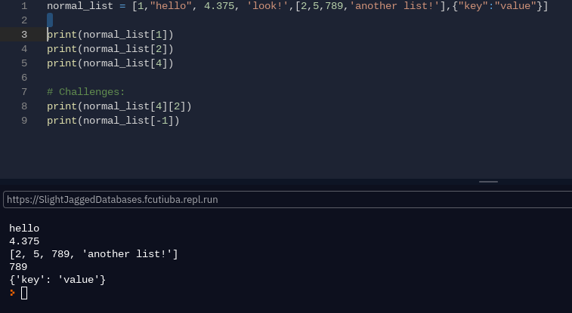

**Float & Integer Practice:**

